PETER KARP - NEW CD Blue Flame
featuring Mick Taylor, Kim Wilson
(Americana / Blues, Nashville, TN)

“PETER KARP IS A STAR. From his muscular slide guitar soloing to his observational and oh-so-true songwriting and, most of all, that soulful expressive voice of his, dripping with innuendo. Dude’s entertaining as hell.”
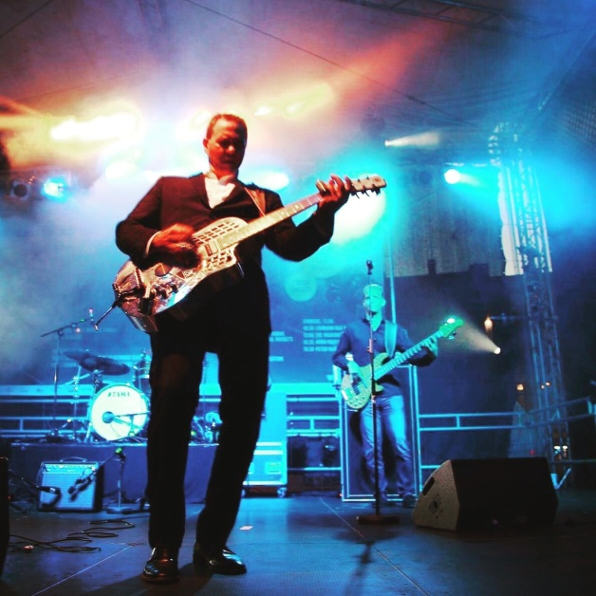
- GOLDMINE MAGAZINE

Songwriter. Guitarist. Singer. Pianist. Bandleader. Peter Karp’s dazzling musical ability is evident throughout "The Blue Flame" the phenom’s 9th full-length LP and third on Rose Cottage Records. Operating within the fiery brand of American roots/blues music that Karp calls "soul-influenced Americana - Blues rock," the album highlights Karp’s gorgeous, rough-hewn vocals and soaring guitar and piano work. But most of all it is his heartfelt, critically acclaimed songwriting amidst a group of masterful musicians that make this record and his live show one of this country’s most sought after live acts.

“Guys like Peter Karp, James Taylor and Bob Dylan embody Americana Blues, and us English guys are inspired by it.” - Mick Taylor, The Rolling Stones

As a songwriter Karp first saw national attention when guitarist Mick Taylor of the Rolling Stones recorded and toured with Karp on his third release, The Turning Point. The momentum continued with the Blind Pig Records release Shadows and Cracks, a record that cracked the top 10 on the Billboard and Blues charts. In 2008 Karp formed The Karp Foley Band with Canadian blues guitarist Sue Foley. With Karp as the principle songwriter, they released two CDs, He Said She Said and Beyond The Crossroads on Blind Pig that went to #1 on the Blues Chart. In 2016 Karp released “The Arson’s Match” a live show with Mick Taylor recorded by Sirius radio at The Bottom Line in NYC, part of a charity project that he started for Ovarian Cancer Research. This was nominated for 2 Blues Blast Awards in 2016 and Best Live Album from Blues 411 Jimi Awards. 2017's "Alabama Town" was in the top 10 on the Blues Charts and has garnered many "Best Of" awards.

“Karp is his own man, an artist who blends roots music styles into something that transcends blues, country, R&B and swamp, John Prine’s wordplay, Joe Ely’s rocking instincts, Billy Joe Shaver’s fatalistic outlook.” - J. Poet – allmusic.com
Going beyond the southern textures of 2017’s, Alabama Town, Karp broadens his sound with the release Blue Flame. Inspired by a conversation with blues songwriter Willie Dixon, he masterfully crafts these 13 original songs by infusing genuine emotion, humor and candor with some funky R&B, southern soul, Americana storytelling and and rock blues. His band gets in on the action too, with special guest Kim Wilson playing some soulful harmonica on the tracks "You Know" and "Rollin' On A Log." Mick Taylor contributes some fine guitar work on "The Turning Point." Karp’s core band stacks the record with blasts of swirling organ, soaring harmonica and a lock-step rhythm section second to none.

"One of the most well-respected songwriters in America.”
Blues Blast Magazine

Ever the multi-tasker, Karp bounces between several instruments, handling electric resonator slide guitar, acoustic guitar — as well as harmonica and piano. Each track driven home with his soulful voice and original songwriting style. On this record, having spent the past year tirelessly playing ever-larger venues and festivals to a burgeoning fan base in Europe and the US The Peter Karp Band continues to carve out his own unique niche, with a sound born in the swamps of New Jersey and the trailer parks in southern Alabama.

"Fans of resonator and slide guitar will surely appreciate Karp’s skillful bluesy touch...beautifully weave touches of folk, country, rock and pop, along with blues... His writing has been compared to that of John Prine and John Hiatt and is impressively backed up by his ability as a musician. This is blues material its finest…" - Chicago Blues Guide

The Peter Karp Band is:

Peter Karp: Vocals, Guitar, piano, harmonica
Thea Florea Drums
Hernandez: Drums
Niles Terrat: Bass
Sebastian Stoltz: Bass
Paul Carbonara: Guitar

• 2016 – RMR Top 50 Blues Rock Song Chart – 7 Songs from “The Arson’s Match”
• 2016 – RMR Top 50 Blues Album & Blues Rock Album Charts – “The Arson’s Match”
• 2016 – Nominee – Blues Blast Music Awards (Best Rock Blues Album & Best Live Blues Recording)
• 2016 – Nominee – Independent Blues Awards (Best Independent Blues Live CD & Best Contemporary Blues Song – “I’m Not Giving Up”)
• 2010 – #10 Billboard Blues Album – He Said She Said (Peter Karp & Sue Foley)
• 2010 – #1 for 6 weeks on the National Blues and Roots Charts – He Said She Said (Peter Karp & Sue Foley)
• 2010 – #1 Roots Music Report Blues Chart – He Said She Said (Peter Karp & Sue Foley)

Music Videos:
https://youtu.be/H3gn6FGYYIY - “I’m Not Giving Up” at Roy’s Hall, NJ
https://youtu.be/LATIxM7ziBI - “The Arson’s Match” (w. Mick Taylor) NYC
https://youtu.be/zaRV2RWrr00 - “Your Prettiness” at City Winery Cellar Sessions NYC
https://youtu.be/KNb8Bxicpmo “Alabama Town” at Don Odell’s TV, MA
https://youtu.be/QeRsxx5NRyQ - Bamberg Jazz and Blues Festival TV compilation, Germany

"Karp's voice is immediately convincing, a big, bold, soul-drenched instrument that makes even his most troubadour-influenced material sound bluesy. In addition, he’s a terrific keyboard player and an elegantly stylish slide guitarist." Steve Pick - AboutBlues.com

"Karp's gruff vocals and bemused, quasi-philosophical writing gives this agreeable platter emotional depth." - Pasadena Weekly

